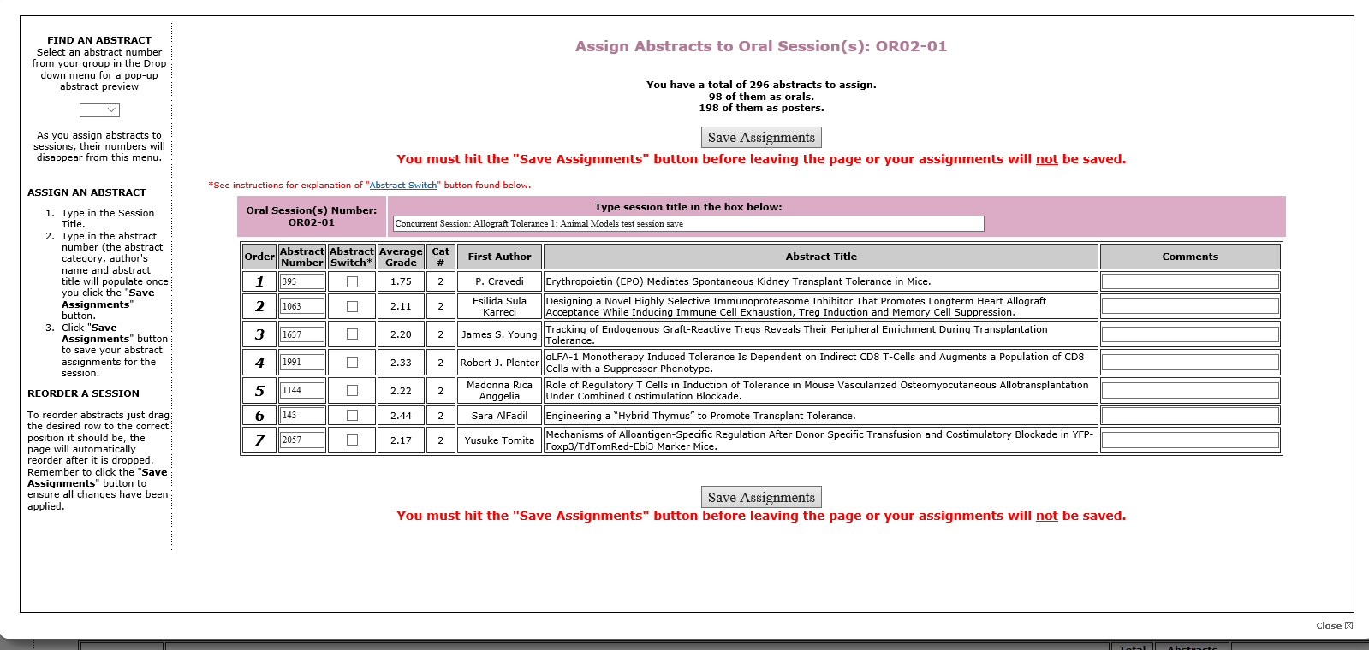

I have three edits all related to the Oral Session pop-up window.

1. At top of the page shows the number of abstracts to assign broken down by Oral and Poster. I would like this removed from this page and only shown on the top of the main Assign/Preview page.
2. If possible, I would like the font size of the word “Close” increased so someone could actually locate it. (This applies to the Oral and Poster assignment pop-up windows) If you aren’t able to increase the font size could you make the font color Red? Either will work.
3. One the lift side of the page, I would like to add step 4 shown as:

Click **Close** in the bottom right corner of the screen to return to the Assign/Preview page.

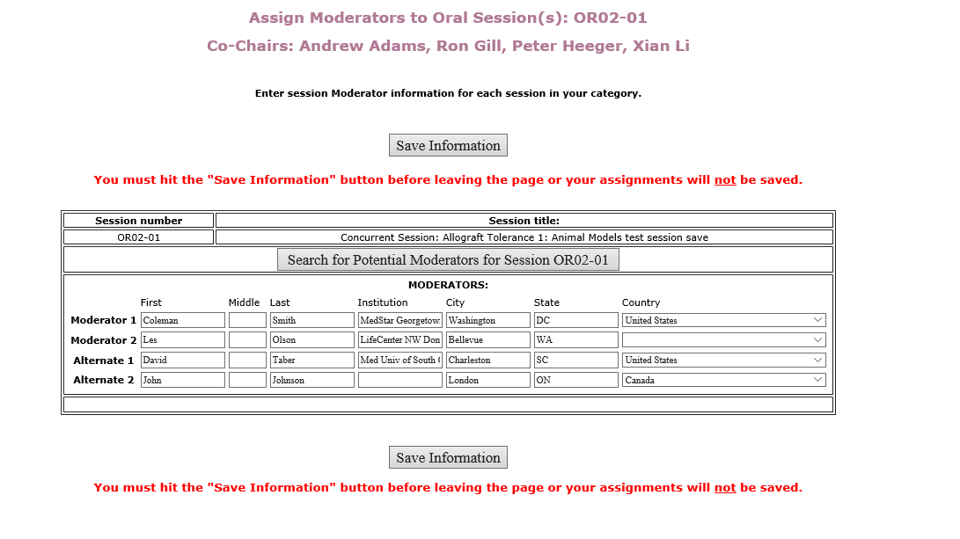

Moderator Assignments (Oral Session Step)

Please add the following text under the Co-chair names: (please center text)

Click “Search for Potential Moderators” below to select moderators and alternates for this session. You must enter two primary moderators and two alternates for each session.

A list of abstract reviewers by category is available on the “Abstract Reviewer List” tab on the site. You may use this list as a reference as you consider moderators for your session.

Delete: Enter session moderator information for each session in your category.